

Tenant ASHP handover draft text
Disclaimer: the below is text to be used in documents produced by you to support tenants. They have been produced as part of the Optiheat project but the creators take no liability for their usage.

Getting the best from your heating
Your home is heated by an Air Source Heat Pump. This works differently from the gas boiler or storage heaters you might be used to. It is designed to run efficiently and keep your bills low, but only if used correctly.

- To save money, keep it running 🔄
Heat pumps work best when they run "low and slow." It costs more money to turn the heating off completely and try to heat a cold house up quickly later. It is cheaper to leave it running gently in the background.
- Radiators will feel cooler. This is normal ❄️
With a gas boiler, radiators get scorching hot. With a heat pump, they will feel lukewarm or cool to the touch. This does not mean it is broken. As long as your room is warm, the system is working.

- Find a comfortable temperature 🌡️
Set your main thermostat between 18°C and 21°C. This is the healthy standard for most adults. If you are cold, turn it up by just one degree and wait 24 hours. Jumping straight to 30°C won't heat the house any faster, but it will cost you a lot of money.

- Keep radiator valves open 👐
Don’t turn radiators off in unused rooms. The heat pump works most efficiently when water flows through the whole system. Turning radiators off makes the pump work harder and use more electricity.

Who to call
INSERT RELEVANT CONTACTS
NOTE CSE offer tenant advise services Advice Projects - Centre for Sustainable Energy

Tenant handover guidance

How your heat pump works
- It takes heat from the air outside
Your heat pump sits outside your home. It works like a fridge in reverse: instead of removing heat to keep food cool, it extracts heat from the outside air to warm your home, even in freezing weather.
- It is designed to run "low and slow"
Unlike gas boilers that blast short bursts of intense heat, heat pumps run continuously at lower temperatures. Think of your heat pump like driving a car. It takes a lot of energy fuel to get a car moving from a complete stop. Once you are up to speed, you use far less energy to simply maintain that pace.
You could also think of it like pushing a swing in a playground. Getting a swing to go high takes a lot of hard pushing at the start. Once it’s swinging, you only need a tiny push every now and then to keep it going. If you stop the swing completely, you have to do all the hard work again.
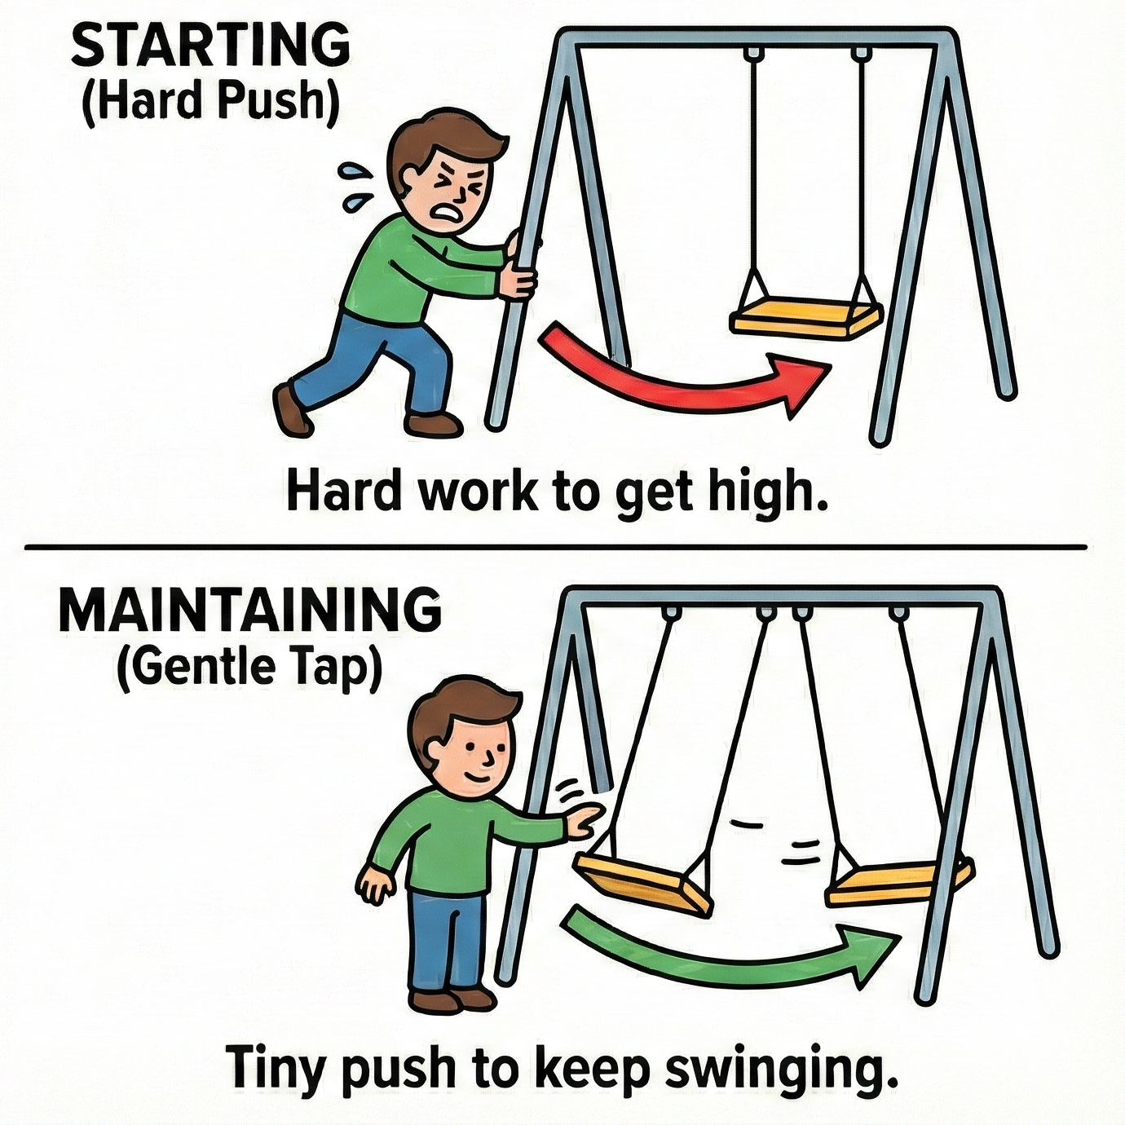
- Your radiators might not feel as hot as before
Heat pumps use cooler water to work efficiently. Because your hand is about 37°C, the radiator might sometimes feel cool to the touch. Don’t worry, your room is still being heated to your desired temperature.
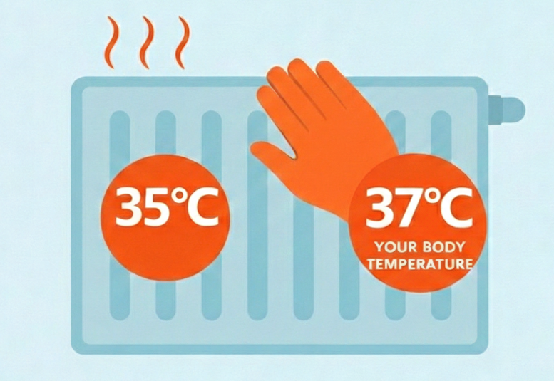
- Hot water is stored at around 55°C
Your hot water should be stored at around 50°C to 55°C. This is hot enough for a bath/shower but not so hot that it wastes electricity. If it is set to 60°C or higher all the time, you are paying to heat water you will just mix with cold water anyway.
- Defrost cycles can make more noise than usual
Your heat pump is self-cleaning. It has an automatic process that melts ice buildup on the outdoor fan, ensuring heating efficiency during cold weather. It typically lasts 5–15 minutes, during which the outdoor fan stops, and steam may rise from the unit.

Heating your home for less
To save money, don’t turn it off.
Because turning the heating off completely can be expensive, use a "setback" temperature for at night or when you are out instead.
- During the day: Set your thermostat to your comfortable temperature (e.g., 20°C or 21°C).
- At night or when out: Don’t turn the heating off. Instead, turn your thermostat down by just 2 or 3°C (e.g., to 18°C), or use your timer's "setback" setting. This keeps walls warm so the system won't have to work as hard to reheat your home later.
Leave your radiator valves open
- Your radiators likely have numbered valves (1–5) on the side. Keep these fully open (on 5 or Max) in your main living areas.
- Too hot? If one specific room is always too hot, turn that radiator valve down slightly (e.g., to 3).
- Warning: Do not close the valves in the room where your main wall thermostat is located. This confuses the system.
Lower the thermostat by 1°C
This can save significant amounts of money over a year.
Check the "Boost"
Ensure the electric immersion heater switch in your cupboard is definitely OFF. It can cost 3 times more to heat your water with a boost compared to a usual heating schedule!

Looking after your system
The outdoor unit (the fan)
- Keep it clear: The box outside needs ventilation. Don’t stack garden items against it. If the air is blocked, the pump works harder and costs more to run.
- Leaves: Occasionally check that the back of the unit isn't clogged with dead leaves.
- Ice: In winter, the unit may look frosty or icy. This is normal. It will run a "defrost" cycle to clear itself. Do not throw hot water over it.
The indoor cupboard
- Not for storage: The cupboard containing the water tank and pipes should not be used as an airing cupboard or for storage. Packing it with towels or boxes can knock valves or overheat the equipment.
- Don't touch the valves: There are many levers and valves in the cupboard. These are for engineers. Please do not turn them.
If your heating stops working, before you call, check:
1. The Thermostat: Is the battery low? Is the target temperature actually higher than the current room temperature?
2. The Power: Has a fuse tripped in your main fuse box? (Look for a switch marked "Heat Pump" or "ASHP").
3. The controller: Is there a red light or an error code? Try turning the system off at the wall, waiting 5 minutes, and turning it back on to reset it.
Who to call
INSERT RELEVANT CONTACTS
NOTE CSE offer tenant advise services Advice Projects - Centre for Sustainable Energy

