
Air Source Heat Pump 5 point check for non technical staff

Acknowledgements: thanks to the manufacturers for supplying the information provided and also Mick Wall for the Vaillant information on his Energy Stats website.

User guidance: This guide has been produced by Bristol City Council (BCC) as part of the Optiheat project and references secondary resources where helpful. BCC take no liability for usage of this form by third parties.

Site Visit Date: Site Visit Time:

Audited by:

Company/Organisation:

Primary details
Installation site address
Installer name (if known)
Installers MCS number (if applicable)
Heat Pump make and model (found on the data plate on the heat pump unit)

- Resident satisfaction/ comfort levels
Suggested questions | Is the heating keeping you at a comfortable temperature, not too hot or cold?  Are any particular rooms too hot or too cold?  Do you have enough hot water at the times of day you need it?  Do you have any concerns about your energy bills related to the heat pump?
Resident’s responses

- System performance check
Item check |  | Details/Information
Find the main system control unit. This is not usually part of the room thermostat  See appendix 1 for examples of what these look like for different models. If your model isn’t listed please google or search youtube using the model number on the controller.  SCOP  Check SCOP and record. If unsure take a picture to go back to later.  Weather compensation  Check if weather compensation is enabled. Main thing here is to check that it is not set on a fixed flow temperature.  Hot water  Record what the hot water is set at  Check all the above against the commissioning sheet if you have one (installers should provide). |  | SCOP for heating  SCOP for hot water  Combined (or if just one scop provided)  Is weather compensation enabled? If so what is the reading.  Hot water temperature

- Heat pump/ Hot water cylinder size
Item check | Details/Information
Check data label on heat pump unit and note the size  Check the rules of thumb in appendix 3 to assess suitability of size | Heat pump size (kw)  Hot water cylinder size (Litres)

- Insulation
Item check | Details/Information
Check all exterior pipework is lagged and sealed correctly. See appendix 2 for examples.  If you can see pipework or feel heat then the lagging hasn’t been done correctly.  Check there is lagging around the hot water tank (appendix 2)  Check the pipework is sleeved and lagged through building fabric as per appendix 2 | Is the outside pipework lagged correctly?  Is the internal pipework lagged correctly?  Is the pipework sleeved and insulated through the fabric of the building?

- External unit
Item check | Details/Information
Check heat pump is level if you have one  Check there is adequate provision of a soakaway for the condensate, see appendix 2 for example | Is the heat pump level  Is there adequate condensate management arrangements e.g. a soakaway

Any other comments?

Recommendations/ next steps?

Appendix 1: Example Heat Pump Control units

Below is guidance for some of the most common heat pump brands to find information that is helpful in the checklist. If you have other heat pump models then using youtube to help is a good idea.

Set-by-step guides to tame and train your heat pump by Mark Thompson is a handy guide around some of the most common controllers out there via the get energy savvy website.

Vaillant

SCOP
Every Vaillant Arotherm installation includes the VWZ AI controller, the white box usually near the hot water cylinder and diverter valve. This makes it the simplest place to check your COP and SCOP. Vaillant call it the Working Figure rather than COP, but it’s essentially the same calculation.
From the main menu press the top left button and go into Yield Indicator. You’ll then see:
Working Figure: Month (Heating)
Working Figure: Month (Domestic Hot Water)
Working Figure: Total (Heating)
Working Figure: Total (Domestic Hot Water)
The monthly figures reset each month, while the totals run from when the system was installed. If you want to keep track of performance over time it’s worth noting down the month values at the end of each month.
Vaillant do note that the Working Figure may be out by up to 20% because it only includes the internal components of the heat pump, not things like external circulation pumps and valves.

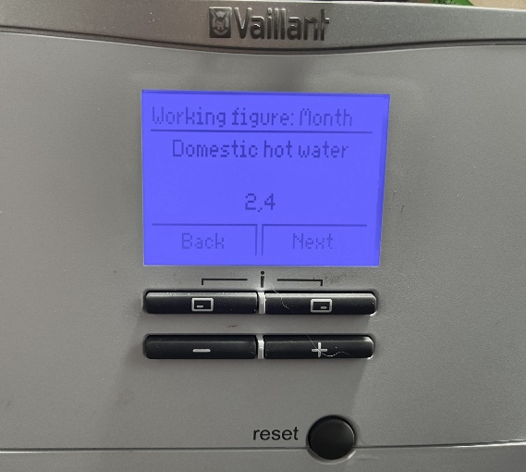
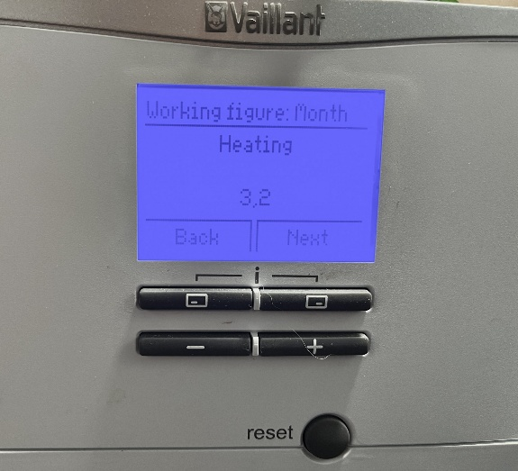

Calculating SCOP with the Sensocomfort Controller
On the Sensocomfort controller, COP isn’t labelled as Working Figure. Instead, you’ll find Environmental Yield and Power Consumption.
From the home screen, choose Information, then Energy Data. Here you’ll see Environmental Yield. To get Power Consumption go back into Energy Data and choose Power Consumption. You can view Heating only, Hot Water only, Cooling, or Installation (all of the above combined). For COP you want the Installation total.
Example below For December 2022 readings were:
Environmental Yield: 1427 kWh
Power Consumption: 631 kWh
Vaillant’s formula is COP = (Yield + Power) ÷ Power, which in this case works out at a COP of 3.26.

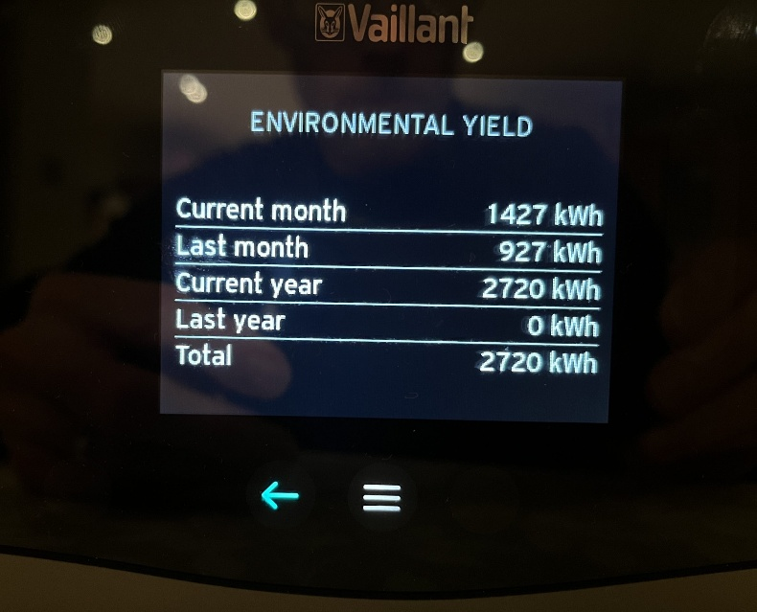
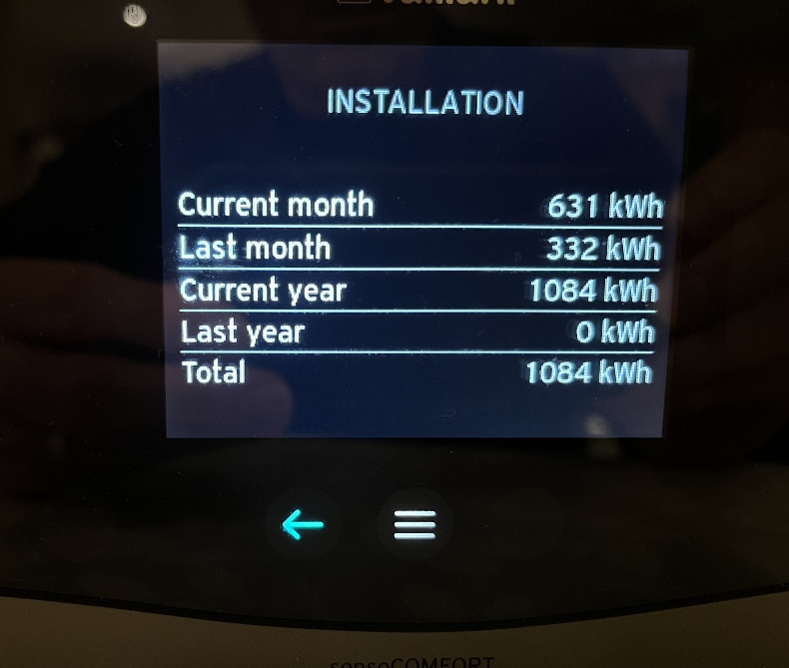

Controller to access key information

How to check weather compensation is enabled
You will find the settings here on the SensoCOMFORT controller: (note use pin ‘00’)
Settings → Installer Level (00) → Installation Configuration → Circuit 1
There are three items of note in that menu:
Heat Curve
Min. target flow temperature
Max. target flow temperature
Recommend leaving the minimum flow at 15 °C and the maximum at 55 °C.

How to check the hot water schedule
Check temperature
Use the Sensocomfort controller and navigate to this menu item
Control → Domestic Hot Water → DHW Temperature → Current DHW temp

Daikin Altherma

Controller to access key information
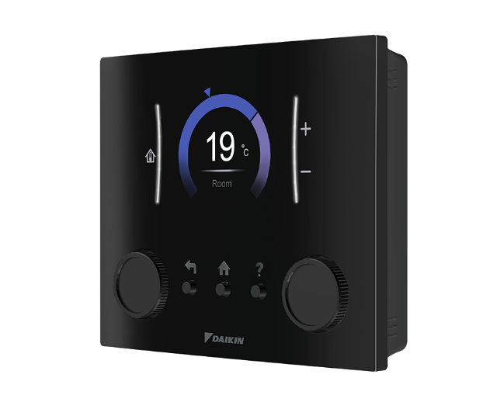

SCOP:
Steps to Check SCOP on Daikin Altherma (MMI Controller):
- Access Menu: Go to the main menu and select "Information."
- Energy Data: Choose "Energy Data."
- Find Metrics: Locate the "Produced Heat" (output) and "Electricity Input" (consumption) values.
- Select Timeframe: Use the controls to filter by day, week, month, or year to get a seasonal (long-term) figure.
- Calculate: Divide total produced heat (kWh) by total energy consumed (kWh) for your SCOP.
- Alternative (App): Use the Daikin Onecta app to view similar energy statistics, although data may be rounded.

How to check weather compensation is enabled
- Access the Menu: Go to the main screen, enter the menu, select the main zone, and navigate to Heating WD Curve.
- View the Curve: A graph displays the relationship between outdoor temperature and required flow temperature (e.g., higher flow temp for colder weather).

Hot water

- View Temperature: Press the left-hand dial to access the menu, then select the "Tank" option to see the current tank temperature.
- Check/Adjust Setpoint: Within the Tank menu, you can see the target temperature (arrow indicator)..
- Schedule Check: Navigate to Menu > Tank > Schedule to view times when hot water is scheduled to heat, often set to for eco or for comfort.

Mitsubishi Ecodan

Please see the below. For more information, please see the operation manual linked HERE.

SCOP:

Enter the menu settings via the top right of the controller as per the below.

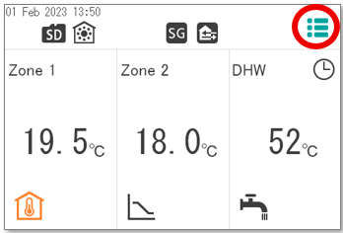

From the menu settings enter the energy page as per the below.

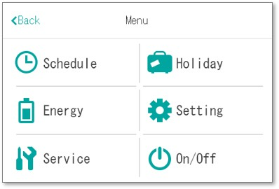

This will show your energy consumption and production.
COP = (Consumption + Production) ÷ Consumption

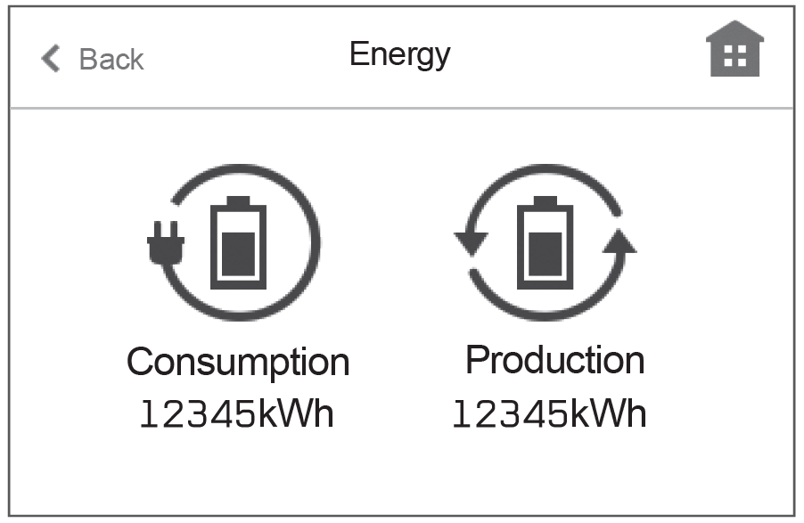

Weather Compensation:

Please see the below.

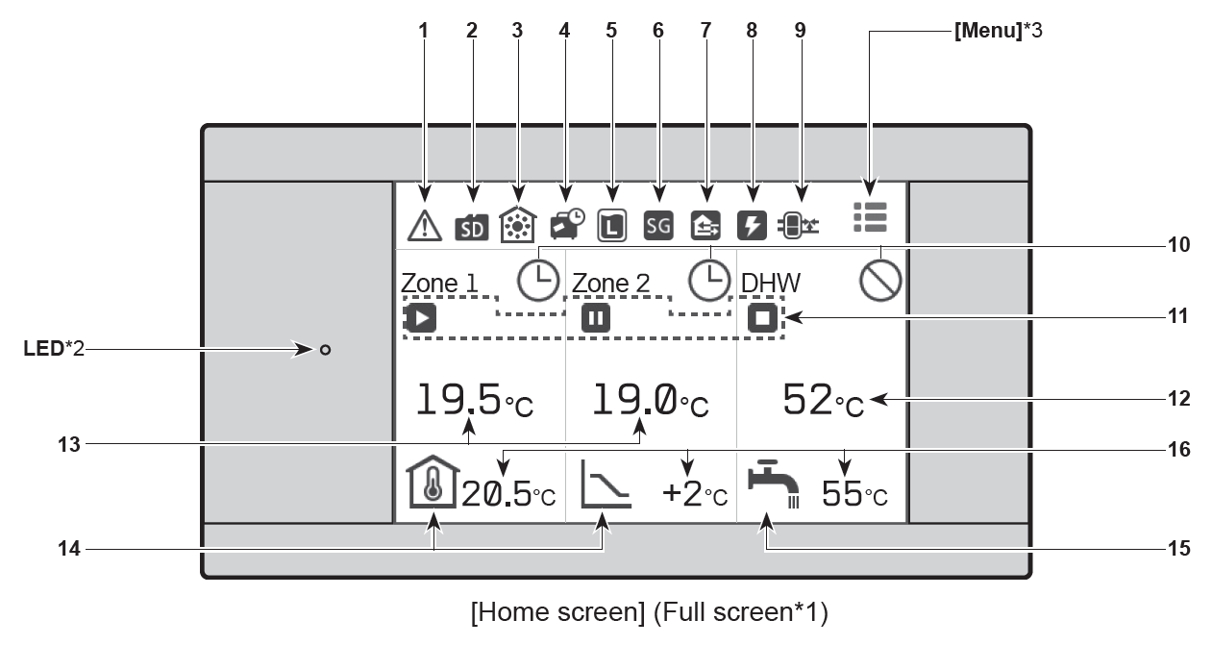

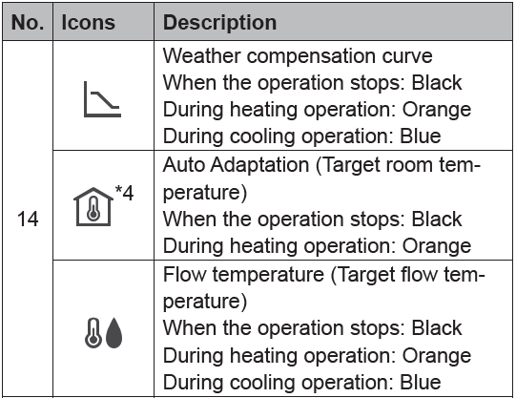

Hot water

As previously enter the menu settings then select the schedule tab which will take you to the below page.

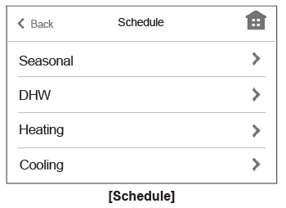
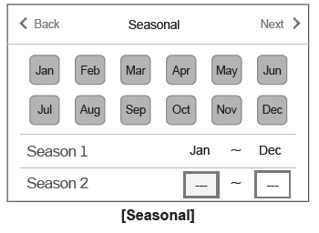

Appendix 2: Pipe lagging and condensate

There are three different categories of pipe insulation to be considered:

1: Exterior - must be Class-O, closed-cell, UV-resistant with wall thickness greater than 19mm.
2: In lofts, unheated “plant-rooms”, garage spaces or below a suspended floor. This should also have high wall-thickness and the joins taped. It may be subject to condensation but not exposed to sunlight and rain.
3: Internal - Can be the more common Climaflex type held with clips such as those sold here.

External ASHP pipe insulation
Exterior insulation needs to have two main characteristics:
- it must be of closed-cell construction to prevent rain or condensation filling up the voids within the material. They are what provide the insulating properties.
- it must be resistant to UV radiation from sunlight.

Neither the common grey Polyethylene (Climaflex) insulation, nor the black nitrile-rubber (Armaflex) insulation satisfy these criteria.
Example of good insulation:
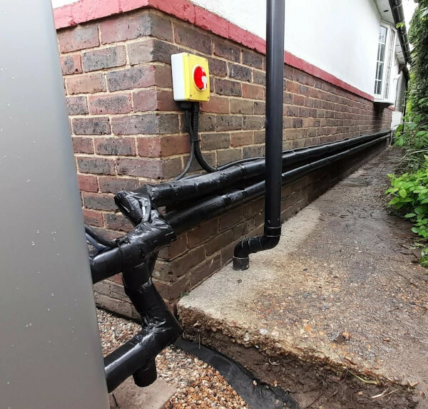
Armaflex pipe insulation (unsplit and self-sealing) with tape for joins

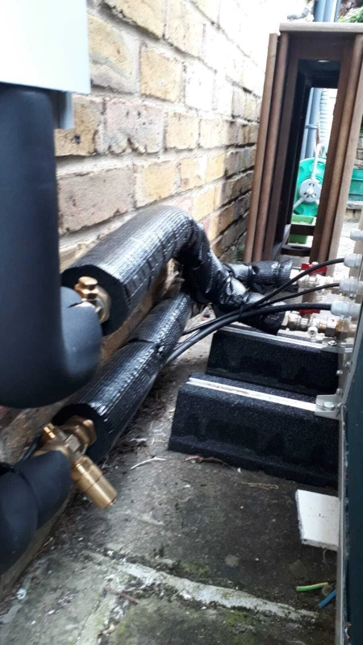
Bad example: if you can feel heat coming out then it’s a good indicator or poor workmanship/ materials. This pipework is also unsupported against the wall.
Insulation should cover not just the external pipework, but also every valve.

Internal insulation

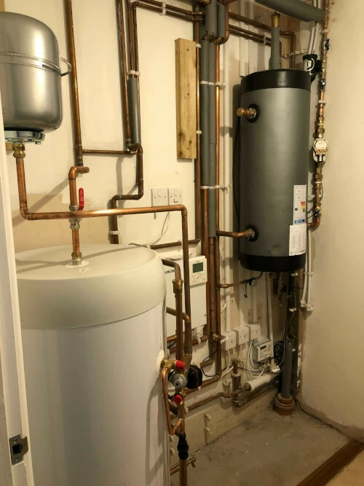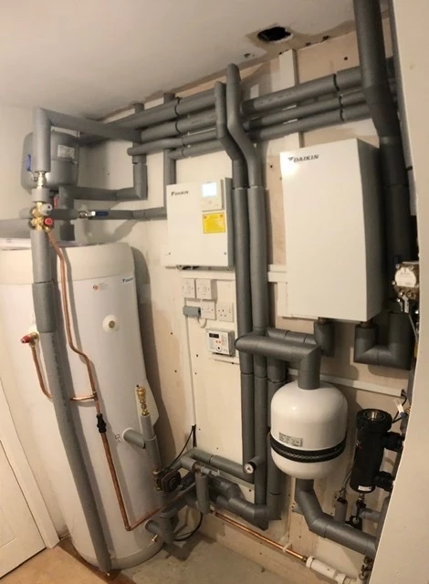
Example of poor internal insulation before and after

Condensate and soakaways

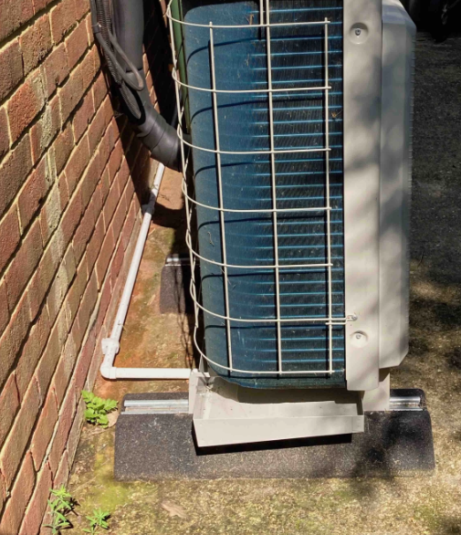

White pipe takes away condensate in this instance


Base made with gravel soakaway.

Appendix 3

Heat pump size rules of thumb.

Heat pumps are often oversized due to poor or none existant heat loss calculations. You can use this chart by Heat Geek to help estimate approximate heat pump size to identify extreme outliers e.g. 2 bed new build shouldn’t need an 11kw heat pump!

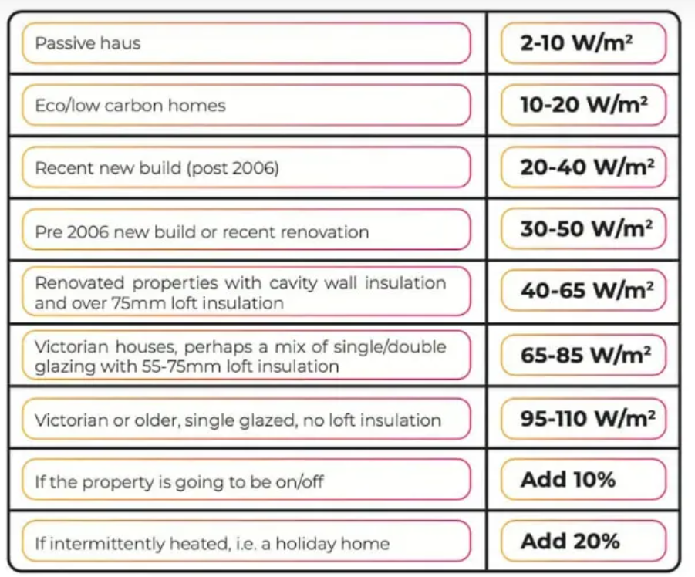

HVACEDUHUB CHEAT SHEET.pdf - Google Drive further cheat sheets here from HVAC Education Hub Home | Hvac Education Hub
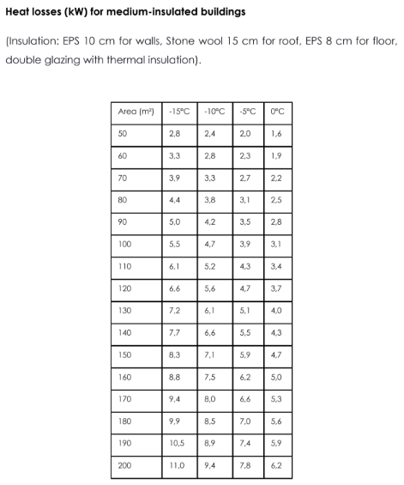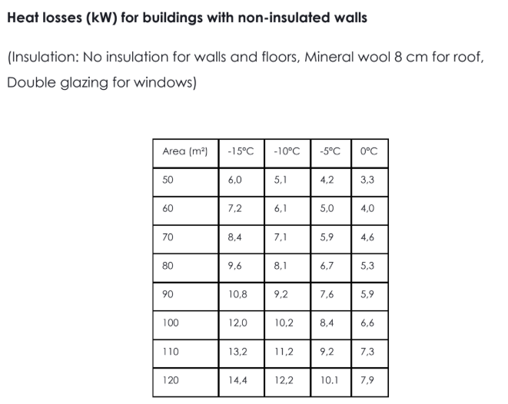
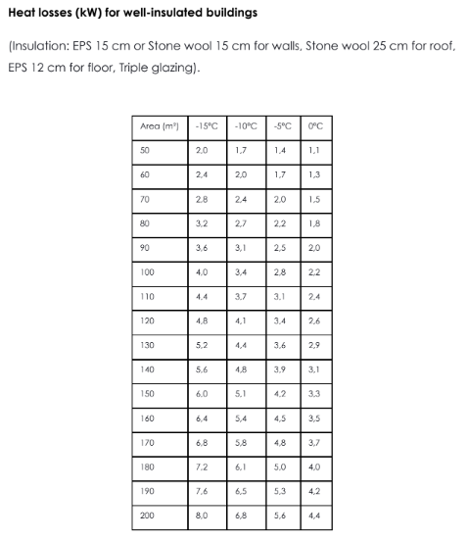

Hot Water Tank size rule of thumb (Thanks to National Trust)

Note the larger heat pump sizes can produce hot water quicker than smaller heat pumps therefore it’s possible to use smaller tanks.
